✴

# Document an existing experience

**TIP**

As you add steps to the experience, move each these “Five Es” the left or right depending on the scenario you are documenting.

Narrow your focus to a specific scenario or process within an existing product or service. In the **Steps** row, document the step-by-step process someone typically experiences, then add detail to each of the other rows.

Customer experience journey map

## Use this framework to better understand customer needs, motivations, and obstacles by illustrating a key scenario or process from start to finish.

When possible, use this map to document and summarize interviews and observations with real people rather than relying on your hunches or assumptions.

Created in partnership with

**SCENARIO**

**Browsing, booking, attending, and rating a local city tour**

### Steps

What does the person (or group) typically experience?

### Interactions

What interactions do they have at each step along the way?

**People:** Who do they see or talk to?

**Places:** Where are they?

**Things:** What digital touchpoints or physical objects would they use?

# Entice

How does someone initially become aware of this process?

4. Detection of temperature and other

parameters are collapsed due to the environment changes

**In industry, the working people can feel safety.**

on-time alerting system which helps to strong admins..

superviosrs to supervisors or floor manaf=gers can talk about the sensors working

# Enter

What do people experience as they begin the process?

in between the monitoring area

And also increasse the productivity.

**Hazardous free workspace**

**1. Network Flow checking**

Before entering into the process they must check the network flow

# Engage

In the core moments in the process, what happens?

check whethere the hardware and software are working properly or not

2. Check hardware working conditions

## 

1. Chances to failure of sensors working

2. Lack of network data flow

3. API is delayed during the network

problem

**Exit**

What do people typically experience

as the process finishes?

## 

1. Workspace hazard avoided

2. safety measures increased

3. People trustabillity increased

4. Productivity increased

**Extend**

What happens after the experience is over?

1. steps should be taken to continue this

work

2. To search advanced techniques to update our system

### Goals & motivations

Increased productivity and employee wellness

Hazardous free industry

Beacon Sensors,Mobile or Pc,MQTT, Cloud services and visual recognizers.

At each step, what is a person’s primary goal or motivation? (“Help me...” or “Help me avoid...”)

### Positive moments

The people when they achieve their desirable goals continuously by using this new technology that time they feel very enjoyable, fun, motivating or delightful.

What steps does a typical person find enjoyable, productive, fun, motivating, delightful, or exciting?

[**Share template feedback**](https://muralco.typeform.com/to/CiqaHVat?typeform-source=app.mural.co)

### Negative moments

What steps does a typical person find frustrating, confusing, angering, costly, or time-consuming?

In this digital system or new technology involved in this product they get little bit confused to how can we use this and in case of lack of network they get trouble to get recieved delayed message it will affect the hole process.

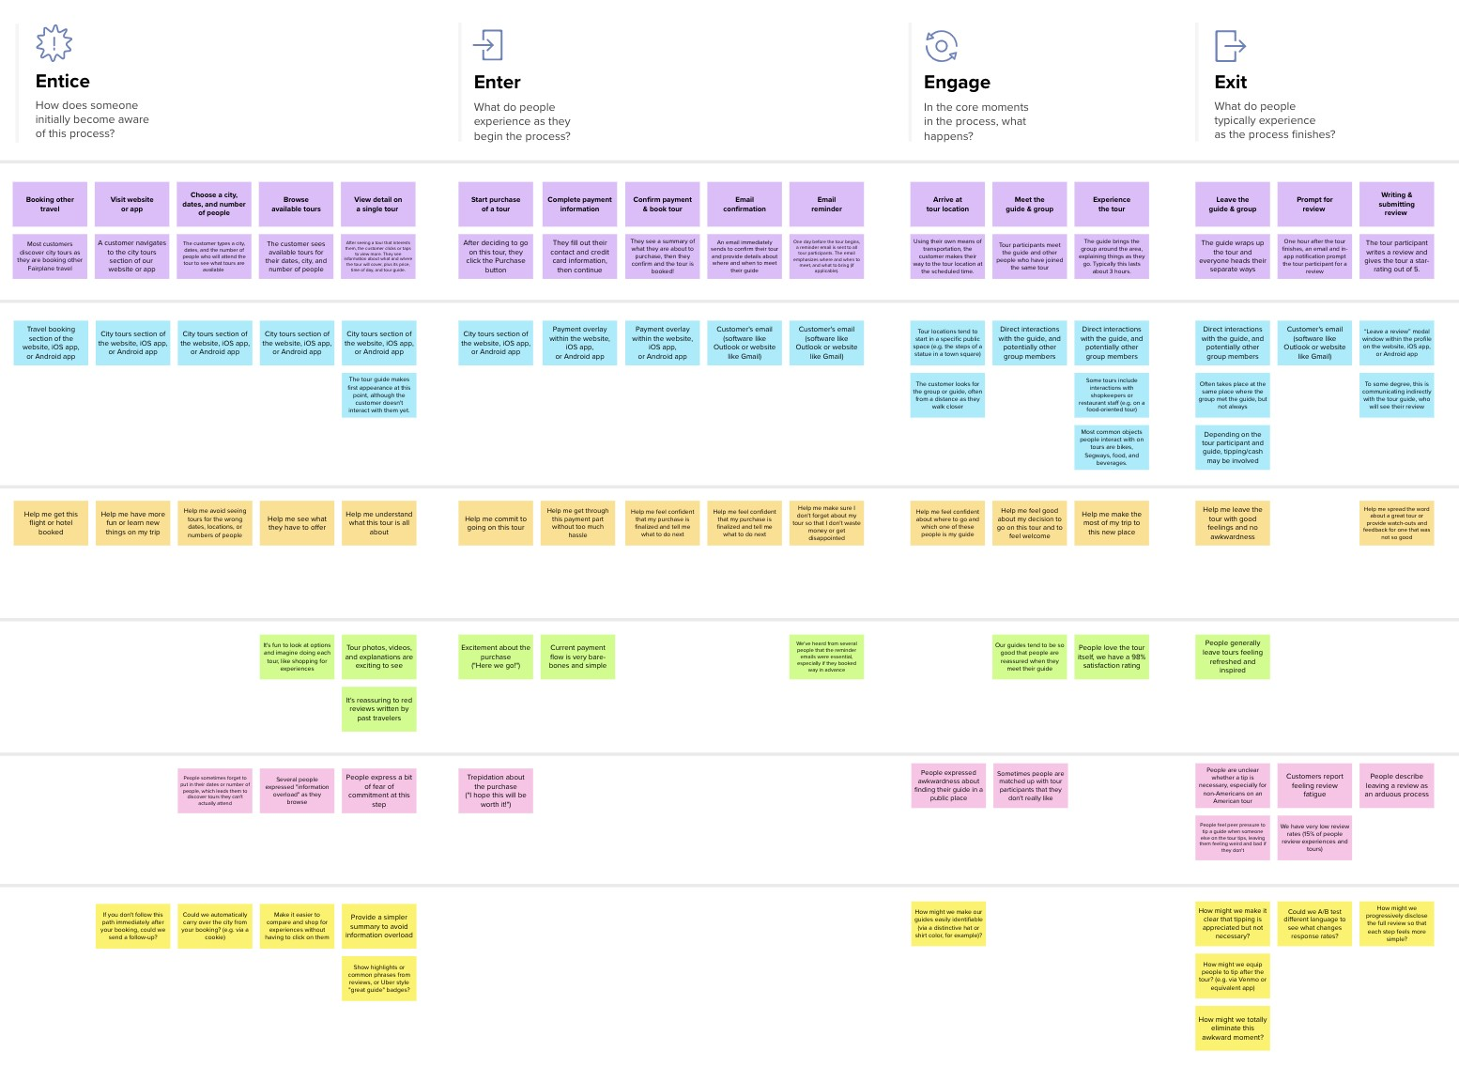

**Template**

### Areas of opportunity

2. Use advanced message queing

technology

1. To add mechine learning technology

to identify the problems

What have others suggested?

**Need some inspiration?**

See a finished version of this template to kickstart your work.

[**Open example**](https://app.mural.co/template/f59f644b-b4b4-47b5-9ed6-3a8c71ceb612/896b31fe-5597-40ef-9b06-3811a1a45ace)